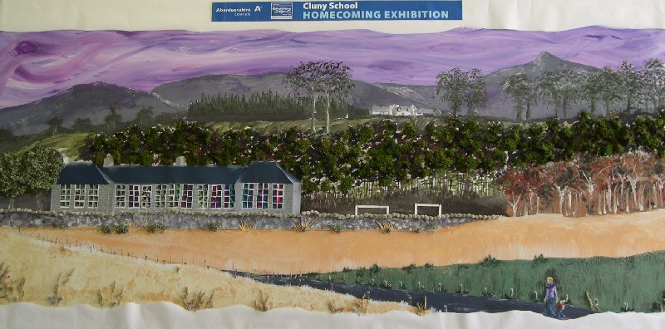

WELCOME BOOKLET

CLUNY SCHOOL
Sauchen
INVERURIE
Aberdeenshire
AB51 7JQ

Telephone 01330 833204

Cluny School is a happy, caring, friendly place
where the children work in a creative,
stimulating environment.

We want you and your children to enjoy your
time at Cluny School.
INFORMATION FOR PARENTS

Curriculum for Excellence (CfE) – The school’s priorities lie in developing literacy and numeracy, and in looking after the children’s health and well-being. Using the ‘outcomes and experiences’ from CfE, we are working with the children to develop skills for learning, life and work. We aim to make the learning relevant and to link knowledge in one subject area to another, helping the children to understand the world and to make connections.

Child Protection
All Cluny staff receive Child Protection training and are PVG disclosed.

Safety - The safety of children at Cluny is paramount and extreme care is taken to ensure that this is always the case. Risk Assessments are carried out for school trips and events.

The School Day
Start 9.00 a.m.
Morning Break 10.30 a.m. - 10.45 a.m.
Lunch Break 12.30 p.m. - 1.30 p.m.
Finish 3.15 p.m. for all children

Emergency Contact – In the event of an emergency, contact will first be made with parents and thereafter with emergency contacts.

Home/School Contact - If at any time you wish to talk with the Class Teacher or Head Teacher about your child's progress or any problem that may arise, please do not hesitate to phone the school or come and see us.

Absence from school - Please inform the school by telephone, e-mail or by letter (in advance) of your child's absence from school. We must account for all children and will contact you if we have not heard and your child does not appear in school.

Medicines - Any medicines must be clearly labelled with your child's name and a written set of instructions on dosage etc. This MUST be handed over to the office staff and the appropriate paperwork must be filled in.

Illness at school – If your child becomes unwell during the school day, we will contact you or, if we cannot get hold of you, the person you have chosen as your emergency contact.

Collection from school – The school must be kept informed of the arrangements for collecting your child from school. You can e-mail the school, but please phone if you do not receive an acknowledgement of your e-mail.
When using the car park, please:
- Reverse park.
- Turn your engine off, if leaving the car.
- Come to our seated area in the playground to pick your child up, before escorting them to your car. We will be asking the children to wait at the seated area for you.
- Park on the road if you arrive slightly late and walk round the path beside the bin store to the seated area to pick up your child. We do not want cars reverse parking while the children are walking past. The only movement of vehicles should be forward as parents leave the car park.
- Do not cross the car park with children or to fetch children. The pavements on either side should be used.

Behaviour Management - We hope to build self-esteem and standards of behaviour through a restorative approach. This is an Alford cluster approach to improving behaviour.

Bullying - At Cluny Primary School, it is seen as the duty of all staff, pupils and parents to reduce, and do all we can to eliminate this unacceptable practice.

School Transport
The school transport providers are Peace Coaches and RS Coaches. All primary pupils who live more than two miles from and attend the school for which they are zoned are entitled to free school transport. Pupils will be allocated an appropriate pick-up/drop off point from the Public Transport Unit.

Snacks – Pupils can bring their own healthy snacks and drinks. However, we also have a tuck-shop each morning.

School Meals - School meals are provided at £2.30 per day. The Council now uses an on-line system of payment. The children will be issued with the School Menu to take home and discuss and choose with parents. Alternatively children may provide their own packed lunch. Drinking water is available each day, but pupils should bring their own water bottle.

Uniform – Recognition Express provide the uniforms at the school. A bulk order is placed each term.
All items have the Cluny logo on them.
We ask the children to wear our school uniform, which includes:
- School sweatshirt / fleece (navy blue)
- Shirt, blouse or polo shirt (white / light blue)
- Trousers or skirt/pinafore (black/grey/navy blue) or gingham dress
- Shoes (preferably not trainers – ideally black/grey)
Children will also need to bring warm waterproof clothing to school.

Homework Bags – Navy Blue homework bags with the school logo are also available.

Monymusk Cluny After-School Club/Breakfast Club
The After-School Club has recently been set up. It is based at Monymusk School and Cluny pupils are transported there at the end of the school day. The club runs straight after school until 6pm, Monday to Friday during term time. The session fee for after school care is currently £9.50. For more information, please contact: monymuskclunyasc.gmail.com

Parent Council - Please support the Parents’ Committee, if you can. The termly meetings are an opportunity for you to express your views and to bring improvements within the school. We, also, greatly appreciate your help with major school events. It’s a great way to meet other parents, too!

Please contact me if you would like to discuss any of these items further.
Thank you.

Ken Girdwood - Head Teacher

What will my child need?

Please ensure that ALL your child’s belongings are named. Finding the owner of an un-named school jumper is a near impossible task.

- SCHOOL BAG: It should fasten securely and be easy for your child to open and close.
- DRAWSTRING SCHOOL P.E. BAG: For your child to store their P.E. kit at their peg. (Cluny P.E. bags are available on the Tesco website, if you wish)
- PAINTING APRON
- PENCIL CASE: Your child will provided with everything that they need. However, they may take colouring pencils and writing pencils if they wish.
- INDOOR SHOES: The children must change into indoor shoes, usually their gym shoes, when in school.
- P.E. KIT: Sports shorts and t-shirt are required. Gym shoes are required for use indoors. Long hair must be tied up out of the face and jewellery must not be worn.
- WATER BOTTLE: Children are encouraged to have a water bottle in class to rehydrate; it must contain water and not juice. There is a water fountain in our First Aid room and the children can take their bottles there to top them up.
- WALLET / PURSE: If your child has to take money to school, please put it in a named wallet or purse.

