Mrs Sangster/Mr Watts
Mrs Sangster will be in class every Wednesday afternoon. The children will be taking part in Bounce Back activities to help them to become more resilient and confident in themselves. They will also have PE with Mrs Sangster.
Mr Watts will be teaching the children about other World Religions on a Thursday morning. This term they will be finding out about Judaism.

Health and Wellbeing
This term P.E. will be on a Monday and Wednesday. Please ensure that your child has their P.E. kit on these days. In P.E with myself, we will be developing our team building and sportsmanship skills, through various sports’ games and challenges.
The children will also be improving their skipping skills with Mrs Paterson for the first 4 weeks on a Friday.

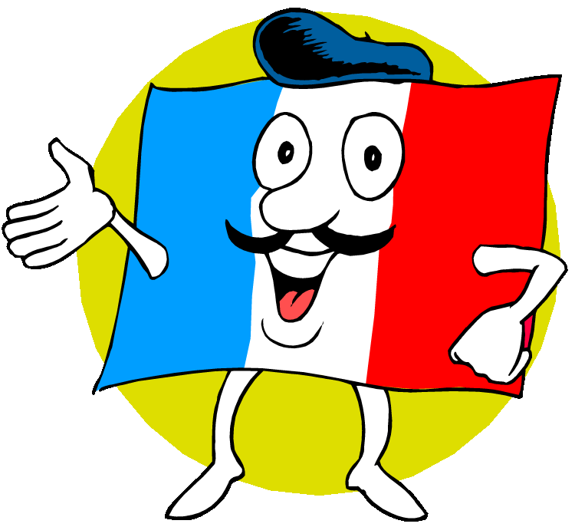
Modern Languages
The children will be learning simple French phrases and words. We will be looking at greetings, numbers and food names.

Homework
Maths homework will be handed out on a Tuesday and returned on a Monday. (This homework will be a maths/literacy board game on alternate weeks.)
The Primary 2 children will also have spelling words to learn each week.

Show and Tell
Show and Tell is on a Friday. The children will be able to take part on alternate weeks. This is a great opportunity for the children to gain confidence when speaking to a larger audience. Please help them to select something appropriate and help them to prepare what they would like to say. The children will also have the chance to answer questions from their peers. Primary 2 will begin in week 1 and Primary 1 will be the following week.

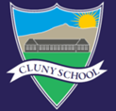

Cluny School
Learning Leaflet
Primary 1/2
Information for Parents/Carers
Term 1 2019

Hope you all had a great holiday and are ready for a new school year!
Mrs Mitchell

Outdoor Learning
We will be going outside as often as we can to enhance our learning opportunities and value the outdoors. Please ensure your child is dressed appropriately and prepared for changes in weather.

Literacy
Reading
The children will have reading twice a week. This will either be on a Monday/Wednesday or Tuesday/Thursday. Please check the reading record in their folder to see which days the children have reading.
Primary 1 will begin with books without words. Please encourage them to use the pictures to verbally create their own story. Please revise the sounds/words they are introduced to each week.
Primary 2 will use their knowledge of phonics to sound and blend unfamiliar words. They will also continue to increase their sight vocabulary and use context clues to help them understand the story.

Spelling/Phonics
Primary 1 will be introduced to two new sounds each week using songs, stories and actions.
Primary 2 will be introduced to a new spelling sound each week with a weekly spell check on a Monday. Various active spelling activities will take place in class to support the children to learn new and recap previously taught sound and words.
Writing
We will be learning to enhance our recount/instruction writing skills which we will link to our topic where possible. These may take different forms such as letters, personal recounts or recipes.
Handwriting will take place weekly where the children will practise the correct formation of letters.
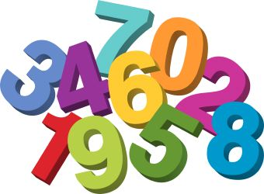
Numeracy
This term Primary 1 will be working with numbers to 10. They will identify and recognise numbers to 10, count forwards and backwards, find the number before, after and in between. They will also learn the correct formation and use one to one correspondence to count.
Primary 2 will be using their previous knowledge of the number bonds to 10 to help them to add to 20.
As a class we will link our topic with Information Handling to carry out simple surveys about food choices.
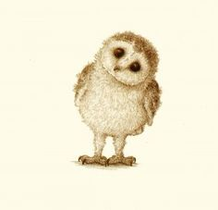
Topic
This term the class will be learning about Food and Health. We will be discussing the foods we need to eat to stay healthy, the different food groups and how much of each one to eat and the importance of hygiene and cleanliness when preparing food. They will also have the opportunity to prepare and taste various foods.
Expressive Arts
This term our art and drama will be linked to our food topic.

