Health and Wellbeing
This term P.E. will be on a Monday and Wednesday. Mrs Sangster will be in every Wednesday and Friday to work with the children on Bounce Back, PE and some art.
Please ensure that your child has their P.E. kit on these days – including clothes and shoes that could be worn outdoors. We have been doing some football in PE, working on our ball control with dribbling and shooting.
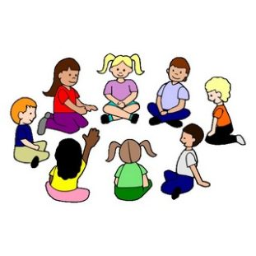
The class will also explore their mental and social wellbeing with Mrs Sangster, following the Bounce Back programme. This will include discussing themes of kindness, resilience and fairness along with the importance of telling the truth, through group activities and circle times.

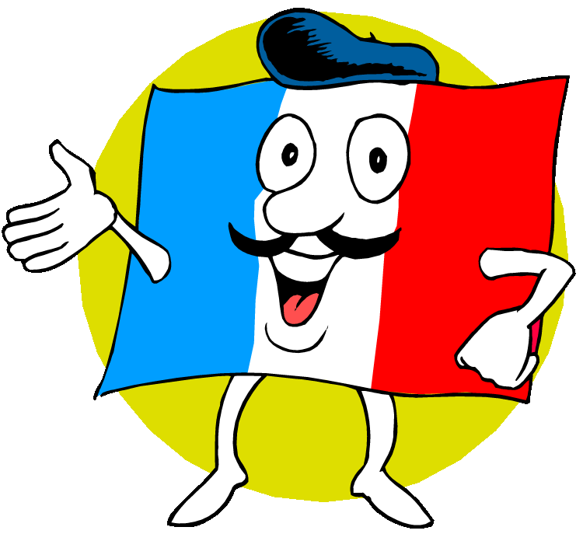
Modern Languages
French will continue to be taught through integrated lessons of the languages. We will be revising greetings in French and learning colours, food, body parts and weather.

Expressive Arts/R.M.E
This term Mr Watts will be teaching RME – with a focus on Judaism. We will link our expressive arts to our Food topic where possible. We will be using a variety of media to create images and learning skills including sketching, shading, collage and wax resist.
Homework
Homework will be handed out on a Tuesday to be returned on the following Monday. We will also complete a monthly homework challenge.
Website

http://cluny.aberdeenshire.sch.uk/

Cluny Primary School
Homework Leaflet
Primary 3/4
Information for Parents/Carers
Term 1
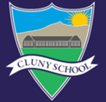

Welcome back to school! I hope everyone had a lovely holiday and it doesn’t feel like too distant a memory!
We have had a great few weeks back at school and the class are settling in well to P3/4, having fun, getting to know each other and learning lots!
Miss Cordiner

Outdoor Learning
Please note that we will try to get outside at least once a week to enhance our learning opportunities and value the outdoors. Please ensure your child is dressed appropriately and prepared for changes in weather. They must have a jacket with them every day and suitable outdoor shoes!

Literacy
Reading
Each reading group will read regularly once, twice or three times a week. Please see reading record book for more information once the reading groups have started. The children will be expected to read some pages of their book at home. We will focus on developing our comprehension skills and our sight vocabulary as well as improving our fluency and expression while reading.
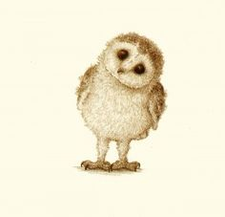
We are also working on our comprehension skills and understanding of author’s craft through our class novel., which is the Owl Who Was Afraid of the Dark!

Spelling
A new spelling sound and list of words will be introduced on a Monday with a weekly spell check on a Friday or Monday. Various active spelling activities will take place in class to support the children to learn new and recap previously taught sound and words.
Writing
We will be learning to enhance our recount and instruction writing skills which we will link to our topic where possible. These may take many different forms. We have already written a personal recount of our holidays on a postcard which are displayed in the class. We will be linking our instruction writing to the topic – Food.
Handwriting will take place weekly where we will practice the formation of our letters and the different joins. The children will be encouraged to join their writing when possible!
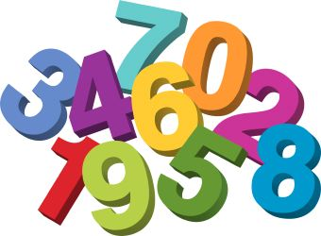
Numeracy
This term we are looking at the importance of place value and zero as a place holder. We will be developing our skills in reading and writing numbers up to 1000 or 10000. We will be using our understanding of place value to compare, order and sequence numbers.
We will also be regularly working on our mental maths skills and problem solving skills. This will involve using the four operations to solve calculations. We will also be developing our ability to work together to try different strategies when solving problems.

Topic/IDL – Food
This term the whole school will be learning about Food. We will link this to aspects of the Wellbeing Wheel – exploring how we can be Safe, Responsible and Included when working with food. Our learning will include looking at food hygiene and the Eatwell Plate.
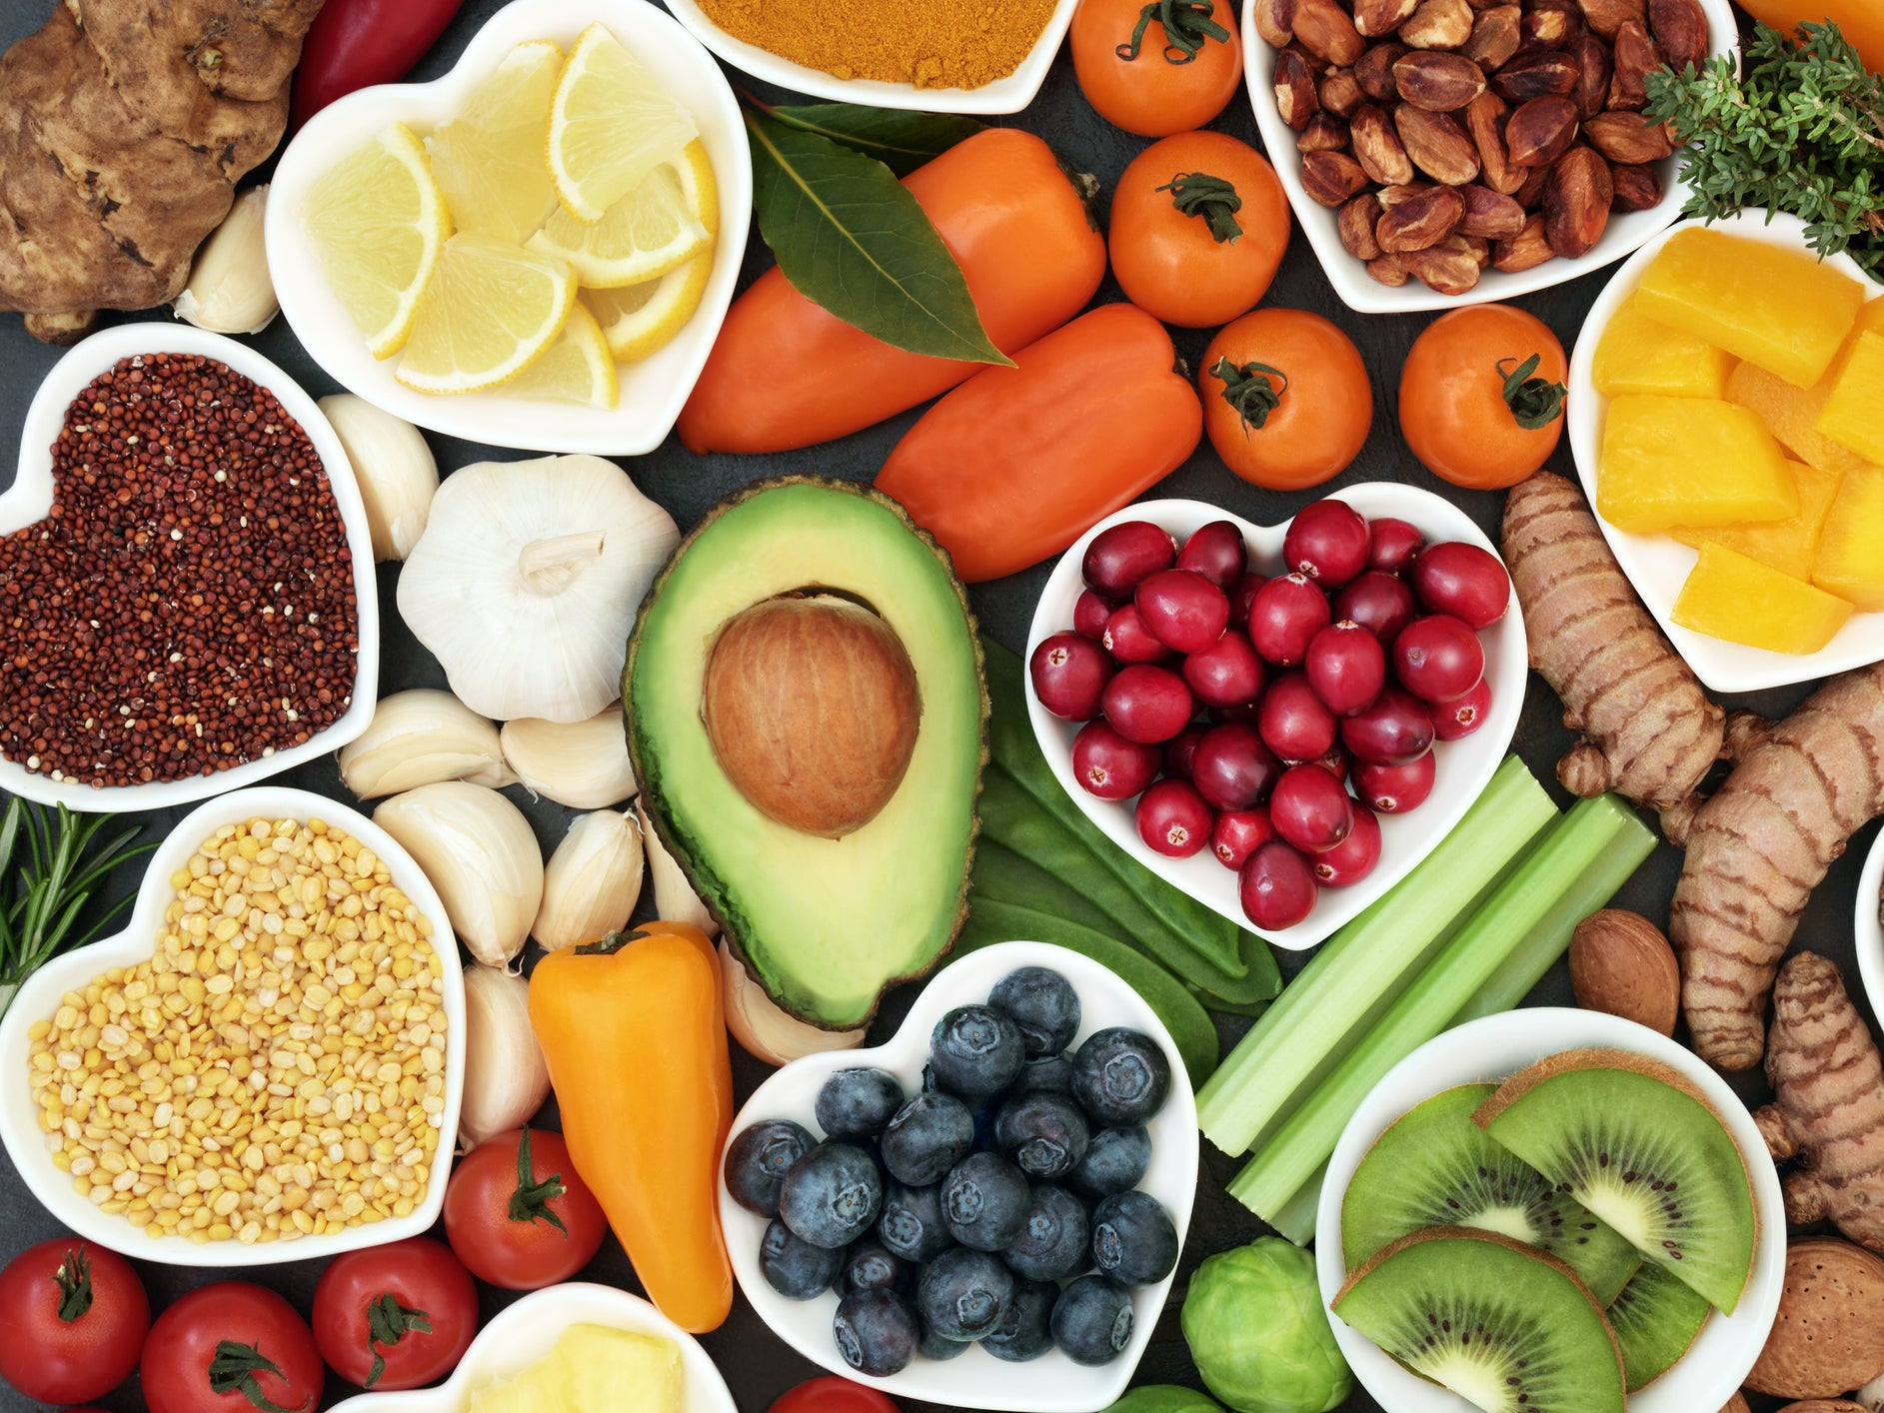
We are also planning to use our understanding of French to develop cross-curricular links and create a French Café for the other children in the school to experience!

