Teaching Staff
Most weeks, Mrs Payne will take the class on Mondays, Tuesdays and Wednesdays. Mrs Gilmour takes the class on Thursdays and Fridays.
There will be times when these days swap. We will endeavour to inform the children of any changes in advance.
Mrs Sangster will be taking the class for part of Wednesday and Friday mornings. She will cover aspects of Health and Wellbeing and Art.
Mr Watts will be teaching R.M.E and Science on a Thursday morning.
Modern Languages
French will continue to be learned this year and this term we will begin with Classroom and ‘All About Me’ vocabulary.

Health and Wellbeing
This term, P.E. will be on a Tuesday and a Wednesday. Please ensure that your child has a P.E. kit in school every day, in case of changes. In weeks 1 to 4, the class are also benefitting from skipping workshops with Mrs Paterson.
The P.E focus this term will be team and invasion games with Mrs Payne and Mrs Sangster. Mrs Sangster will be using the ‘Bounce back’ programme to explore the themes of kindness, resilience and fairness along with the importance of telling the truth, through group activities and circle times. We will reinforce these personal qualities across our day to day activities.
Homework
Homework will be handed out on a Tuesday and returned on a Monday.
There will be spelling words to consolidate (spelling activities provided) and an active maths activity each week. Your child will also have a reading book to take home (comprehension activities provided)
There will also be whole school homework challenges once a month.

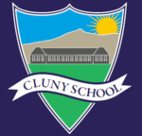
Learning Leaflet
Primary 4,5,6
Information for Parents/Carers
Term 1

Welcome to Primary 4,5,6
We are all settling back into the school routine and are excited for our year ahead and are enjoying getting to know the children as part of their new class group.
Mrs Gilmour and Mrs Payne

Outdoor Learning
Please note that the school now has improved access to the woodland area adjacent to the school football field. We are planning to utilise this to enhance our learning opportunities. Our initial focus will for outdoor learning will be maths. Mrs Gilmour has begun leading shape work outside. Please ensure your child is dressed appropriately and prepared for changes in weather.
Literacy
Reading
Activities will based on reading group or class novel will take place throughout the week.
We will also continue to encourage and plan for focused independent personal reading in class through DEAR (Drop Everything and Read). The children will be encouraged to bring a book in from home, or choose one from the class book corner for DEAR time.
Spelling
A new spelling focus, and word list will be introduced on a Monday with an informal weekly spelling check on a Friday. Various active spelling activities will take place in class to support the children to learn new and recap previously taught sounds and words.
Writing
This year we are coordinating our writing approach to assist us assess and monitor progression across the school.
This term our focus is recount and instruction writing skills and will be linked to our topic where possible.
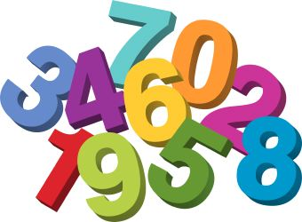
Numeracy
This term we are learning about place value and developing our skills in reading and writing, comparing and ordering 4, 5, and 6+ digit numbers (depending on level/ year group). We will also begin to explore rounding and estimating.
Mrs Gilmour will be exploring 2D and 3D shape using active strategies and focus on mental maths and problem-solving skills.
Topic/IDL
This term the topic is Food and will be learning about food labelling, advertising and food safety. We also plan to do some making, eating and tasting as the term progresses!
The topic will also give us the opportunity to enable the P4s and P6s to join with their peers from the other classes for some lessons.
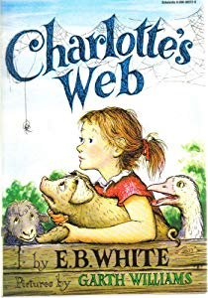
The classic novel ‘Charlotte’s Web’ also gives us a context for exploring the ‘Farm to Fork’ aspect of the topic.
Expressive Arts/R.M.E
This term we will be learning about Judaism with Mr Watts.
Mrs Payne will also use the Charanga programme to share and enjoy music in the classroom. ‘Food, Glorious Food’ will be a song we learn this term.
The whole school will attend ‘Theatre in School’ performances on 26th and 27th September at Dunecht Hall.

